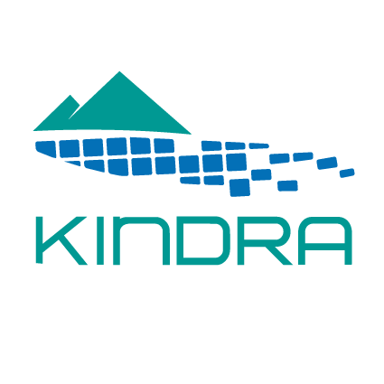
KINDRA Final Conference
MAKING GROUNDWATER VISIBLE/ACCESSIBLE/ESTEEMED
Date:
27th of February 2018
Venue:
Académie Royale de Belgique, Rue Ducale 1, 1000 Bruxelles, salle Prigogine

Organizers:
KINDRA consortium
Background:
Groundwater and hydrogeology-related research activities cover a wide spectrum of research areas at EU and national levels. However, groundwater issues are quite often either ignored or considered only in insufficient detail and separated from the associated surface water bodies, despite of its critical importance as renewable, high-quality, naturally protected (but still vulnerable) resource that has significant impacts on both surface water bodies and ecosystems. The KINDRA project (Grant Agreement No. 642047, www.kindraproject.eu) created a critical mass for scientific knowledge exchange of hydrogeology research, to ensure wide applicability of research results, including support for innovation and development. The overall objective of the project is to take stock of our current knowledge of hydrogeology through an inventory of research results, activities, projects and programmes at national and international scale.

Aim
The final conference is aimed to communicate the results achieved by the project, from the new classification system, to the inventory of hydrogeological products (EIGR) and its content of more than 2000 metadata, to be used for evaluating the state-of-the-art of European research & knowledge on groundwater. Results of inserted data have been critically analyzed, to identify modern challenges, trends and gaps in groundwater science and practice. Obtained results need to be discussed with institutions, associations, stakeholders and decision makers, with the aim to identify a road map for developing policies, strategies, and management options at European level, able to highlight and correctly evaluate the importance of groundwater for both human requirements and environmental needs, in the framework of the circular economy, the water-food-energy nexus, the zero-waste goal, the sustainable development goals and the optimization of natural resources.
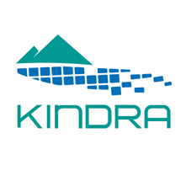

Draft program:

Section 1: Opening session
Chairperson: Isabel Fernandez - European Federation of Geologists
9:00-9:10 | Welcome EFG
9:10-9:30 | Member of Parliament (to be confirmed)
9:30-9:50 | European Water Policy on Research and Innovation  Representative of Directorate Climate Action and Resource Efficiency, DG Research and Innovation
9:50-10:10 | European Environmental Water Policy  Elisa Vargas - WG C, DG Environment
10:10-10:30 | Coffee break
Section 2: KINDRA outcomes
Chairperson: Carlos Martínez Navarrete - Geological Survey of Spain (IGME)
10:30-10:50 | KINDRA project: aims, expectations and final results  Marco Petitta, Project Coordinator - University of Rome Sapienza
10:50-11:10 | KINDRA Classification  Klaus Hinsby - Geological Survey of Denmark and GreenLand (GEUS)
11:10  11:30 | KINDRA Inventory  Clint Garcia Alibrand - Environmental and Water Agency of Andalusia (REDIAM)
11:30-11:50 | KINDRA Gaps analysis  Peter van der Keur - Geological Survey of Denmark and GreenLand (GEUS)
11:50-12:20 | Discussion  Q&A
12:20-13:20 | Lunch break
Section 3: KINDRA inventory potential users
Chairperson: Heidi Barlebo- - Geological Survey of Denmark and GreenLand (GEUS)
13:20-13:40 | Tom Diez - De Watergroep, Brussels
13:40-14:00 | To be confirmed - EuroGeoSurveys
14:00-14:20 | Johannes Grath - CIS WG Groundwater
14:20-14:40 | Teodora Szocs - Vice President International Association of Hydrogeologists
14:40-15.10 | Coffee break
Section 4: Future opportunities
Chairperson: Alecos Demetriades - consultant
15:10-15:30 | GeoERA information platform  Coordinator Yvonne Schavemaker - TNO Geological Survey of the Netherlands  Klaus Hinsby - Geological Survey of Denmark and GreenLand (GEUS)
15:30-15:50 | ICT4Water  Lydia S. Vamvakeridou-Lyroudia, Exeter University
15:50-16:10 | NAIAD - nature-based solutions and green/blue infrastructure  Morten Ejsing Jørgensen - City of Copenhagen
16:10-16:30 | Water Information Network System (WINS) UNESCO  Alejandro Iglesias Campos - Intergovernmental Oceanographic Commission of UNESCO
16:30-16:50 | Subsol & the case of Rotterdam  Koen Zuurbier - KWR Watercycle Research Institute
16:50-17:40 | Panel Discussion  JPE of KINDRA
16:50-17:40 | Debate
 | Closing section: Chairperson: Marco Petitta
17:40-18:00 | Philippe Quevauviller - European Commission

